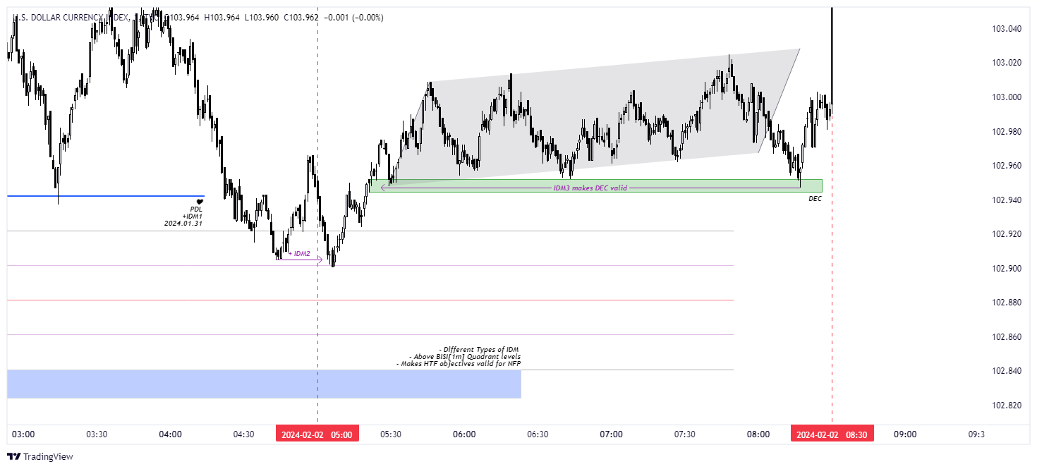

🟢 [https://www.tradingview.com/x/KQV4nom3/] DXY LTF Multiple IDM

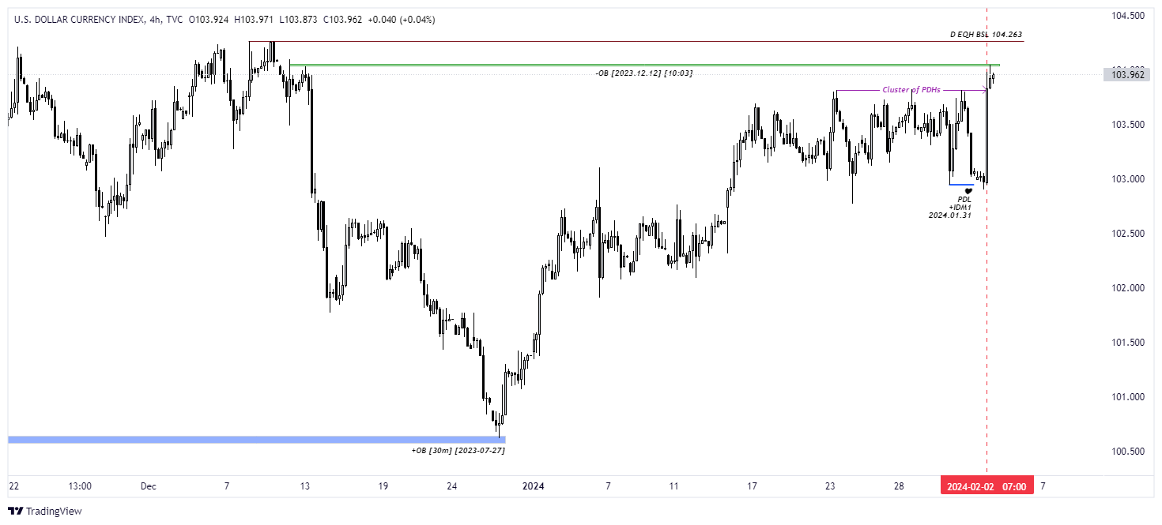

🟢 [https://www.tradingview.com/x/Rslfw1Zp/] DXY HTF +Expansion